CHAPTER-1
INTRODUCTION

Water is one of the most essential resources for agriculture and daily human activities. In many rural and remote areas, the availability of reliable electricity for operating water pumps is limited. Traditional water pumping systems depend on grid power or diesel engines, which increase operational costs and contribute to environmental pollution. Therefore, there is a growing need for an efficient, economical, and eco-friendly solution for water pumping.
Solar energy is one of the most abundant and renewable energy sources available. It can be effectively utilized to power water pumps using photovoltaic (PV) panels. Solar-powered water pumping systems are widely used in agricultural irrigation and rural water supply due to their low operating cost, minimal maintenance, and environmental benefits. However, the lack of proper monitoring and control in such systems can lead to inefficient operation and wastage of resources.
The advancement of the Internet of Things (IOT) has enabled the development of smart systems that can be monitored and controlled remotely. By integrating IOT technology with solar water pumping systems, it becomes possible to track important parameters such as water level, motor status, voltage, and current in real time. This data can be accessed through mobile applications or cloud platforms, allowing users to monitor and control the system from anywhere.
In this project, an IOT-based solar water pumping system is designed using a DC motor directly powered by solar panels, without the use of a battery. Eliminating the battery reduces system cost, maintenance requirements, and energy losses. The system operates during sunlight conditions and uses a microcontroller (NodeMCU/ESP8266) along with sensors to collect and transmit data to the cloud.
The proposed system also provides automation features, where the pump can be switched ON or OFF based on water level conditions or user commands. This helps in preventing water wastage, avoiding dry running of the motor, and improving overall efficiency.
This project aims to develop a smart, cost-effective, and environmentally friendly IoT-based solar water pumping system that ensures efficient water management with minimal human intervention, making it highly beneficial for farmers and rural communities

CHAPTER-2
OBJECTIVES

The primary objective of the IoT-Based Solar Water Pumping System is to design and develop an intelligent, automated, and energy-efficient system that utilizes solar energy for water pumping and integrates IoT technology for real-time monitoring and control. In many rural and agricultural areas, access to reliable electricity is limited, making it difficult to operate conventional water pumps. This project aims to provide a sustainable and cost-effective solution by using solar power to run a DC motor pump without the need for battery storage. At the same time, IoT integration enhances system efficiency by enabling remote access, automation, and continuous performance monitoring. The following are the detailed objectives of the proposed system:

1. Real-Time Monitoring of System Parameters
One of the major objectives of this system is to enable real-time monitoring of important parameters such as water level, motor status, voltage, and current. Continuous monitoring allows users to track system performance at any time and helps in identifying abnormalities such as sudden voltage drops or motor issues. The collected data is transmitted through the IoT module and displayed on a mobile application or cloud platform, ensuring accurate and up-to-date information.

2. Efficient Utilization of Solar Energy
The system aims to make effective use of solar energy for water pumping applications. Solar panels convert sunlight into electrical energy, which is directly used to operate a DC motor. By eliminating dependency on conventional power sources, the system reduces electricity costs and supports the use of renewable energy. This objective ensures that available solar energy is utilized efficiently during sunlight hours.

3. Automation of Water Pump Operation
Automation is a key objective of this project. The system is designed to automatically switch the pump ON or OFF based on water level conditions. For example, when the water level is low, the pump turns ON, and when the required level is reached, it turns OFF automatically. This reduces manual intervention, saves time, and ensures efficient water usage.

4. Remote Monitoring and Control Using IoT
Another important objective is to provide remote access to the system. Through IoT platforms such as mobile apps or web dashboards, users can monitor system status and control the pump from anywhere. This is especially useful for farmers who cannot always be physically present at the field. Remote access improves convenience and ensures better system management.

5. Prevention of Water Wastage
Water conservation is a critical aspect of modern agriculture. The system aims to prevent water wastage by controlling the pump operation based on real-time sensor data. Automatic switching of the pump ensures that water is supplied only when needed, avoiding overflow and unnecessary usage.

6. Protection of Motor from Dry Running
Dry running is a common problem that can damage water pumps when there is no sufficient water source. One of the objectives of this system is to protect the motor by automatically turning OFF the pump when the water level is too low. This increases the lifespan of the motor and reduces maintenance costs.

7. Operation Without Battery Storage
Unlike conventional solar systems, this project is designed to operate without a battery. The DC motor is directly powered by solar panels, which reduces system complexity, cost, and maintenance requirements. Eliminating the battery also avoids energy losses associated with charging and discharging, making the system more efficient.

8. Fault Detection and Alert Mechanism
The system aims to detect faults such as low water level, motor failure, or abnormal voltage conditions. When such issues occur, alerts are sent to the user through IoT platforms. This allows quick action to be taken, minimizing damage and improving system reliability.

9. Low-Cost and Energy-Efficient Design
Another objective is to develop a system that is affordable and energy-efficient. By using components like NodeMCU (ESP8266), sensors, and relay modules, the system can be implemented at a low cost. This makes it accessible to farmers and rural communities with limited financial resources.

10. Support for Sustainable Agriculture and Rural Development
The project promotes the use of renewable energy in agriculture, reducing dependence on fossil fuels and grid electricity. It supports sustainable farming practices by providing an eco-friendly and efficient irrigation solution. This contributes to rural development and encourages the adoption of modern technology in agriculture

CHAPTER-3
SYSTEM DESIGN

3.1 EXISTING SYSTEM:

In traditional solar power setups, monitoring and maintenance are primarily carried out through manual inspection and basic electrical measuring instruments. These systems do not include advanced automation, remote accessibility, or real-time data analytics. The information available to users is often limited to simple indicators such as battery charge level, inverter status, or occasional manual readings of voltage and current. While these systems function adequately for basic energy generation, they lack intelligent features that enhance efficiency, reliability, and predictive maintenance.

In many existing solar power systems, users rely on inverters or charge controllers that display only fundamental parameters like voltage, current, and battery status. These readings must be checked physically at the installation site, making continuous monitoring difficult, especially for remote solar farms or rooftop installations located on high buildings. Such dependency on manual observation often leads to delayed detection of faults, such as panel degradation, wiring issues, shading effects, or unexpected drops in power output.

Another limitation of the existing system is the absence of automated data logging. Without consistent historical data, users cannot analyze trends, detect gradual performance decline, or plan maintenance. Solar panels might lose efficiency over time due to dust accumulation, environmental changes, or aging, but traditional systems rarely capture these patterns, leading to energy wastage and reduced lifespan of equipment.

Additionally, existing systems lack remote accessibility. Users need to be physically present near the setup to check performance parameters. This is inconvenient for large solar farms, rural electrification programs, and installations spread across multiple sites. In case of system failure, users may not notice the issue until significant power loss has already occurred.

Moreover, traditional systems do not include notification or alert mechanisms. If batteries overheat, panels stop generating power, or the inverter malfunctions, the system cannot automatically inform the user. This increases downtime and requires frequent technical visits to ensure proper functioning.

The lack of integration with cloud platforms, smart devices, or IoT communication technologies further limits the capabilities of the existing system. Without internet-based connectivity, real-time insights, automated control, and predictive analytics are impossible.

In summary, the existing solar monitoring systems are manual, inefficient, and lack intelligence and connectivity. These limitations highlight the need for an IoT-enabled solution that provides real-time data, remote monitoring, automated alerts, and advanced analytics to enhance overall system performance and energy management.

LIMITATIONS OF EXISTING SYSTEM:

The existing solar power monitoring systems rely heavily on manual observation and basic electrical instruments, which create several technical and operational limitations. These shortcomings reduce system efficiency, cause delays in fault identification, and limit the ability to optimize solar energy generation. The major limitations are listed and explained below:

Lack of Real-Time Monitoring

Traditional systems do not provide continuous or real-time data regarding solar power generation, battery status, or environmental conditions. Users must manually check the system at intervals, which can lead to overlooked faults and inefficiencies.

No Remote Accessibility

Existing systems require physical presence to inspect performance indicators. Users cannot monitor solar panel output or battery health remotely. This makes it inconvenient for large solar farms, industrial installations, or systems deployed in rural or inaccessible locations.

Absence of Automated Alerts and Notifications

There is no mechanism to send warnings or alerts when the system encounters issues such as low battery voltage, overheating, panel malfunction, or sudden drops in power output. The absence of automated alerts increases downtime and can lead to equipment damage.

Limited Data Logging and Analysis

Traditional systems do not store performance data over long periods. Without historical data, users cannot analyze trends, detect gradual efficiency losses, or plan preventive maintenance. This reduces the overall lifespan of the solar equipment.

High Manual Dependency

The system depends heavily on human intervention for inspection, analysis, and troubleshooting. This manual dependency increases the workload, introduces human error, and reduces accuracy in monitoring and reporting.

Inability to Detect Early Faults

Many issues such as dust accumulation, wiring problems, shading, inverter faults, or battery health degradation are detected late because the system does not continuously analyze data. Late detection leads to energy loss and higher maintenance costs.

No Integration with Smart Technologies

Existing systems lack compatibility with modern technologies like IoT, cloud servers, mobile applications, and automation tools. This limits the system's ability to become part of a larger smart home or smart grid ecosystem.

Poor Scalability

Manual monitoring systems are not suitable for large-scale solar farms or distributed solar installations. Expanding the system requires more manpower and resources, making scalability inefficient and costly.

Ineffective Energy Management

Because users cannot continuously track energy generation and consumption, load balancing becomes difficult. This results in poor energy optimization and increased reliance on grid electricity

3.1 PROPOSED SYSTEM

The proposed System introduces a smart, automated, and real- time monitoring solution that overcomes the limitations of traditional solar power setups. The system integrates sensors, microcontrollers, wireless communication modules, and cloud platforms to provide uninterrupted, accurate, and remote observation of solar energy generation and usage. It enables continuous tracking of key parameters such as voltage, current, power output, temperature, battery level, and load consumption, ensuring that users have complete visibility and control over their solar installations.

At the core of the proposed system is an IoT-enabled microcontroller such as ESP8266 or ESP32, which collects data from various sensors and transmits it to a cloud platform or mobile application using Wi-Fi connectivity. This automated data flow eliminates manual intervention and ensures that users receive up-to-date information at all times. The system supports online dashboards like Blynk, Thing speak, Firebase, or MQTT, enabling users to access performance metrics from any location using smartphones or computers.

One of the major improvements of the proposed system is real-time monitoring and analytics. Continuous data capture allows the system to detect fluctuations in power output, identify inefficiencies, and alert users instantly in case of abnormalities such as overheating, unexpected drops in solar generation, or battery malfunction. This ensures timely maintenance and prevents potential failures.

Another important feature of the proposed system is the integration of automated alerts and notifications. If the solar panel’s performance falls below a predefined threshold or if any component exhibits abnormal behaviour, the system sends immediate alerts through push notifications, SMS, or emails. This feature enhances system reliability and drastically reduces downtime.

The proposed system also includes cloud-based data logging, enabling detailed analysis of long-term energy production and consumption trends. This data helps users understand seasonal variations, identify peak generation hours, and improve energy planning. Such analytics also support predictive maintenance, allowing technicians to address issues before they escalate.

Furthermore, the system enhances energy management by assisting users in optimizing load distribution. By comparing real-time generation with consumption patterns, users can run high-power appliances during periods of maximum solar output, reduce dependence on grid electricity, and ultimately lower energy costs.

Scalability and compatibility are also major strengths of the proposed system. It can be easily expanded to accommodate additional sensors or multiple solar installations. Whether used in households, industries, educational institutions, or large-scale solar farms, the system offers flexibility without requiring major hardware modifications.

In addition, the proposed system supports remote accessibility, making it ideal for installations in remote or inaccessible locations. Operators can monitor performance, troubleshoot issues, and handle maintenance planning without physically visiting the site.

Advantages of Proposed System:

The proposed System offers a wide range of advantages compared to traditional manual monitoring methods. By integrating advanced IoT technologies, sensors, and cloud platforms, the system becomes smarter, more efficient, and far more reliable. The major advantages are listed and explained below:

Real-Time Monitoring

The proposed system continuously monitors voltage, current, power output, battery status, temperature, and load consumption in real time. This ensures accurate and up-to-date information, allowing users to identify performance changes instantly.

Remote Accessibility

Users can access the solar system’s data from anywhere using a smartphone or computer. Through IoT platforms like Blynk, Thingspeak, or Firebase, real-time dashboards allow monitoring without physical presence at the installation site.

Automated Alerts and Notifications

The system provides instant alerts in case of abnormalities, such as sudden power drops, overheating, low battery voltage, or equipment malfunction. These alerts help prevent damage, reduce downtime, and ensure timely maintenance.

Enhanced System Efficiency

By analysing real-time and historical data, users can identify issues like shading, dust accumulation, or panel degradation early. This leads to better maintenance planning and improved overall efficiency of the solar installation.

Data Logging and Analytics

Cloud-based data storage allows continuous logging of solar energy production, consumption trends, and system performance. Users can view historical graphs, monthly reports, and performance summaries for better decision-making.

Predictive Maintenance

With continuous monitoring and analytics, the system can predict faults before they become critical. Early detection of issues such as battery degradation or wiring faults reduces repair costs and increases system lifespan.

Energy Management and Optimization

The proposed system helps users plan load distribution more effectively by comparing generation and consumption patterns. This improves energy utilization and reduces dependency on grid power.

Reduced Manual Intervention

Automation eliminates the need for frequent manual checks. This decreases human effort, minimizes errors, and ensures more consistent monitoring even in remote areas or large solar farms.

CHAPTER-4
PROJECT DESIGN

The project design of the IoT-Based Solar Power Monitoring System focuses on creating a smart, efficient, and automated platform capable of monitoring solar power generation and usage in real time. The design integrates hardware components such as sensors, microcontrollers, and communication modules with software tools, cloud platforms, and mobile dashboards. The ultimate goal is to achieve seamless interaction between data acquisition, processing, transmission, and visualization, ensuring user convenience and system reliability.

The design begins with solar panels as the primary source of energy generation. The output from the solar panel is measured using current and voltage sensors, which serve as the main feedback components for monitoring power generation. A microcontroller – typically an ESP8266 or ESP32 – acts as the central controller. It collects sensor data, processes it, and transmits information to the cloud through Wi-Fi connectivity. This microcontroller is chosen for its low power consumption, built-in wireless communication, and high reliability in IoT applications.

To support off-grid systems, a battery bank and charge controller are included in the design. The battery’s health and charge level are continuously monitored, ensuring that the system provides clear information about storage capacity, backup availability, and charging efficiency. Temperature sensors may also be included to monitor the thermal conditions of the panels or battery, preventing overheating and prolonging system life.

4.1 BLOCK DIAGRAM : IOT Based Solar Powwer Monitoring System

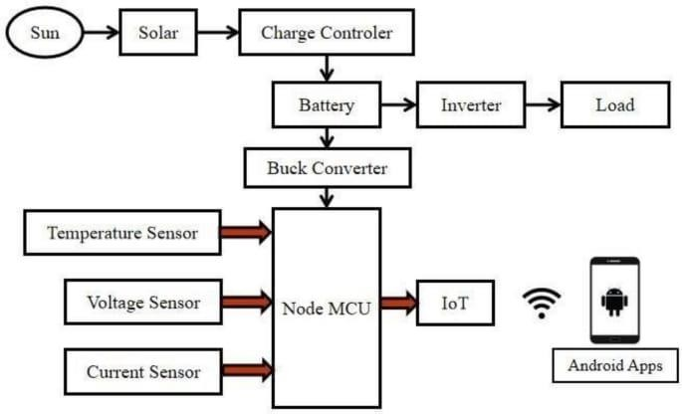

Fig 4.1: Block Diagram
Of the IOT Based Solar Water Pumping System

4.3HARDWARES USED:

- NodeMCU ESP8266 Development Board

- DHT11 Temperature & Humidity Sensor (USB-Type Module)

- 12V DC Cooling Fan

- Single Channel Relay Module (5V)

- LM2596 Buck Converter Module

- 16×2 LCD Display (with I2C board)

- Voltage Sensor Module

- Lithium-Ion Battery Pack (2-cell 18650 Batteries)

- BMS (Battery Management System) Protection Board

- Rocker ON/OFF Switch

- DC Barrel Jack Input Socket

- Solar Panel

- Connecting Wires (Male-Female / Jumper Wires)

NodeMCU ESP8266 Development Board

The NodeMCU ESP8266 is a powerful, low-cost Wi-Fi microcontroller module used in IoT-based applications due to its built-in wireless networking capability and high performance. It operates on a 32-bit Tensilica microprocessor, making it significantly faster and more advanced than traditional 8- bit microcontrollers. The board supports Lua scripting and Arduino IDE programming, making it flexible and user-friendly for beginners and professionals. With multiple GPIO pins, ADC support, PWM, I2C, SPI, and UART interfaces, it can easily connect with a wide range of sensors and modules.

In IoT solar monitoring systems, NodeMCU acts as the central controller that collects data from sensors such as voltage sensors, temperature sensors, and environmental monitors. It processes the data and uploads it to cloud platforms like Thingspeak, Firebase, or Blynk via its Wi-Fi connectivity. This enables real-time monitoring and remote access through smartphones or computers. The board operates at 3.3V and requires stable power regulation, often provided through a buck converter in such systems.

Its compact size, energy efficiency, low cost, and reliable communication capabilities make it ideal for solar monitoring projects. Additionally, built-in flash memory allows the device to store code and small datasets. The USB interface simplifies programming and debugging. Due to its integration of microcontroller and Wi-Fi in a single device, the NodeMCU dramatically simplifies IoT system design by eliminating external communication modules. Overall, the ESP8266-based NodeMCU is a versatile and efficient controller that plays a critical role in enabling automation, data logging, cloud connectivity, and remote monitoring in renewable energy applications.
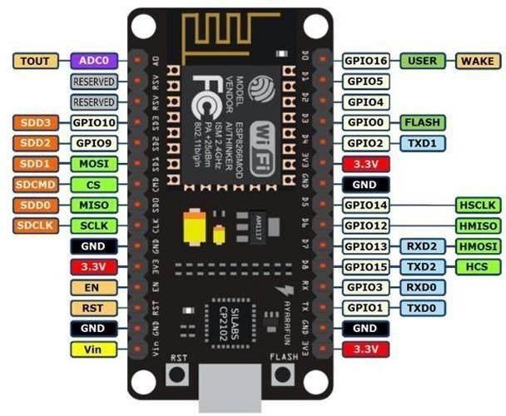

DHT11 Temperature & Humidity Sensor

The DHT11 is a low-cost digital sensor used for measuring environmental temperature and humidity. It combines a thermistor for temperature measurement and a capacitive humidity sensor in a single compact unit. The DHT11 module includes an internal microprocessor that processes sensor readings and outputs a calibrated digital signal, making it simple to interface with microcontrollers like NodeMCU ESP8266.

It operates in the range of 0–50°C for temperature and 20–90% RH for humidity, with reasonable accuracy for small to medium projects. The sensor uses a single digital pin for communication and requires no analog interface, reducing system complexity. In IoT-based solar monitoring systems, the DHT11 helps analyze how environmental conditions affect solar panel performance. High temperature may reduce panel efficiency, while humidity indicates atmospheric moisture conditions that may influence energy generation.

The module shown in the image comes with a USB-type base to simplify wiring and improve stability. It operates at 3.3V–5V, making it compatible with most microcontrollers. It sends data in the form of digital packets at intervals, typically requiring a delay of 1–2 seconds between successive readings.

Though basic, the DHT11 offers good stability, low power consumption, and easy integration. It is widely used in environmental monitoring, home automation, and smart agriculture. The sensor’s ability to provide real-time temperature and humidity data makes it essential for projects requiring environmental awareness.
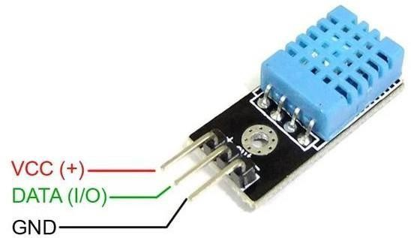

12V DC Cooling Fan

The 12V DC cooling fan is an electromechanical device used to provide active air circulation for cooling electronic components and maintaining system temperature. In IoT-based solar monitoring systems, the fan can be automatically controlled through a relay to reduce the temperature of batteries, charge controllers, or solar enclosures. High temperatures can negatively affect battery life and reduce solar panel efficiency, thus cooling systems play a vital role in maintaining optimal performance.

The fan operates on 12V DC and consists of a motor with multiple blades that generate airflow when energized. It can be switched ON/OFF automatically by the NodeMCU through the relay module based on temperature readings from sensors like DHT11. This automation helps protect the system from overheating and extends the lifespan of electronic components.

The DC fan offers advantages such as low power consumption, high airflow efficiency, long operational life, and low noise. Its compact size makes it suitable for embedded and portable projects. The fan runs at speeds ranging from 1200 to 3000 RPM depending on voltage, design, and power supply. It is commonly used in computers, power supplies, battery storage boxes, and cooling cabinets.

In the system diagram, the fan is powered via the relay module for electrical isolation and safe high- current switching. The relay ensures that the NodeMCU does not directly handle the fan’s high current load, preventing damage to the microcontroller. In summary, the 12V DC cooling fan serves as a critical protective component that maintains temperature stability and enhances the reliability of solar monitoring systems.
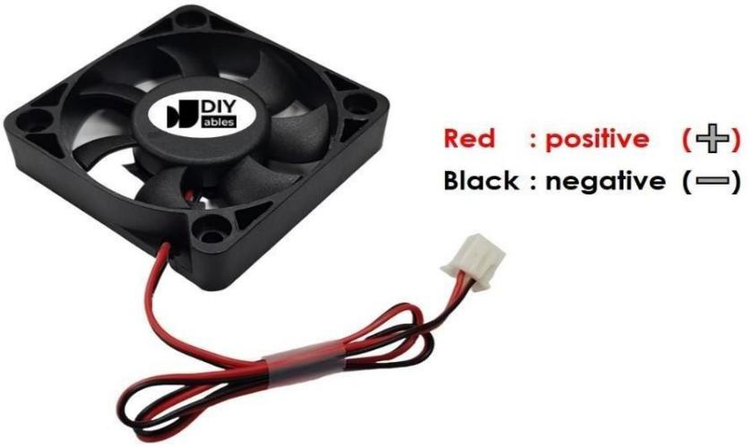

Single Channel Relay Module

A single-channel relay module is an electromechanical switching device used to control high-voltage or high-current loads using a low-power signal from a microcontroller such as the NodeMCU ESP8266. It acts as an electrically isolated interface between low-power control circuits and high- power devices like fans, pumps, or lights. The relay module includes a coil, switching contacts (NO/NC), and a transistor driver circuit that enables safe triggering using a 3.3V or 5V logic signal.

In an IoT-based solar monitoring system, the relay plays a critical role in automating the control of loads such as cooling fans or external appliances based on real-time sensor data. For example, if the DHT11 sensor detects a rise in temperature, the NodeMCU sends a control signal to activate the relay, which in turn switches ON the cooling fan. This automation enhances safety, protects the battery and electronics from overheating, and improves overall efficiency.

The relay module provides complete isolation through its onboard optocoupler in some designs, ensuring that high-voltage spikes do not affect the microcontroller. It offers switching capacity typically up to 10A at 250VAC/30VDC. The module contains indicators like an LED that glows when the relay is activated, helping in debugging and testing.

Due to its reliability, safety, and ease of use, the relay module is widely used in home automation, industrial control systems, power management devices, and IoT projects. It allows the microcontroller to control electrical devices that operate at higher power levels than the MCU can directly handle
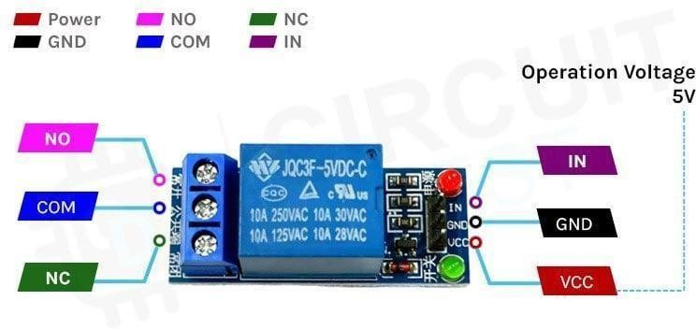

LM2596 Buck Converter

The LM2596 Buck Converter is a high-efficiency step-down DC-DC voltage regulator capable of converting higher DC input to a stable lower DC output. It operates using switching technology rather than linear regulation, offering superior efficiency (up to 92%) and minimal heat generation. The module can accept input voltages typically ranging from 4.5V to 40V and delivers an adjustable output voltage between 1.25V and 35V depending on load requirements.

In the IoT solar power monitoring system, the LM2596 module plays a key role in powering the NodeMCU and other low-voltage electronics. Since solar panels and battery packs may output higher voltages (e.g., 12V), the buck converter safely steps this voltage down to 5V or 3.3V for microcontroller operation. This ensures stable and noise-free power, which is essential for proper functioning of Wi-Fi communication and sensor readings.

The module features a potentiometer for fine voltage adjustment, input/output terminals, and onboard filtering capacitors to reduce electrical noise. It is compact, low-cost, and highly reliable, making it ideal for embedded systems. Over-current and thermal protection improve the safety of connected devices.

The LM2596 ensures that sensitive components such as sensors, LCD displays, and microcontrollers receive consistent power, regardless of fluctuations in solar output or battery levels. This stability is crucial for long-term IoT operation.
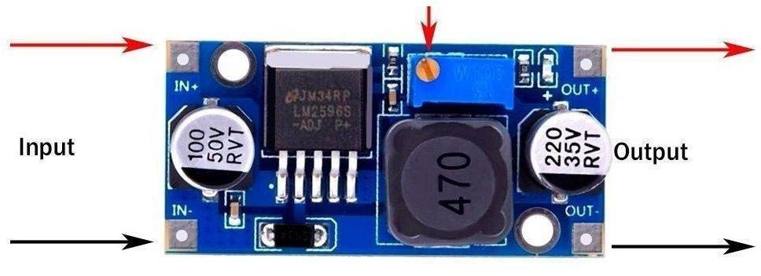

16×2 LCD Display

The 16×2 LCD display is a widely used alphanumeric display capable of showing 16 characters per line over two lines. It is based on the HD44780 controller, which allows easy interfacing with microcontrollers through either 4-bit or 8-bit communication modes. In many modern circuits, an I2C interface is added at the back of the LCD to reduce wiring complexity and allow communication using just two lines—SDA and SCL.

In an IoT-based solar monitoring system, the 16×2 LCD acts as a local display unit that presents essential real-time information such as voltage, current, battery status, temperature, humidity, and system warnings. This ensures that even if the user is not connected to the internet or cloud dashboard, the system remains informative and operational on-site. The LCD is especially useful during testing, installation, and debugging phases.

The display operates at 5V and has an adjustable backlight controlled by a small potentiometer, which helps improve visibility in various lighting conditions. The characters are displayed using dot matrix segments, ensuring clear readability. The LCD consumes very low power, making it suitable for solar- powered systems.

With its reliability, ease of use, affordability, and compatibility with Arduino and ESP8266/ESP32 libraries, the 16×2 LCD remains one of the most practical choices for embedded projects. It enhances user interaction by providing immediate feedback on system performance without requiring smartphones or cloud access.
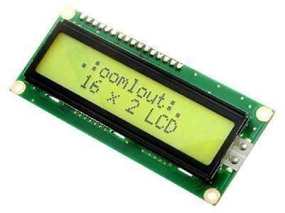

Voltage Sensor Module

A voltage sensor module is used to measure DC voltage in a safe and scalable manner. The typical module consists of a voltage divider circuit that reduces a high input voltage (up to 25V or more) to a lower voltage range (0–3.3V or 0–5V) compatible with microcontroller ADC pins. By reading the scaled-down voltage, the system can calculate the actual voltage value using simple mathematical formulas.

In the context of a solar power monitoring system, the voltage sensor plays a crucial role in measuring both solar panel output voltage and battery voltage. This helps in understanding power generation, storage status, charging behaviour, and load performance. Without such monitoring, it becomes difficult to detect under-voltage or over-voltage situations that may harm batteries or connected devices.

The module generally includes resistors arranged in a divider network, along with screw terminals for secure wiring. It interfaces directly with analog input pins of the NodeMCU ESP8266. Since the ESP8266 operates at 3.3V ADC, the voltage sensor ensures that no high voltage directly enters the microcontroller, preventing permanent damage.

The voltage sensor module provides stable readings, easy installation, and electrical safety, making it essential for solar projects. It helps in real-time voltage logging, remote tracking, and automated control based on measured values.
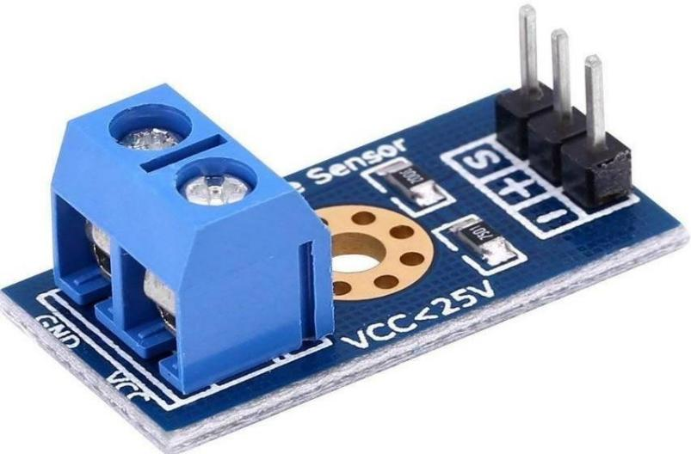

DC MOTOR

A DC motor (Direct Current motor) is an electrical machine that converts electrical energy into mechanical energy using direct current (DC) power. It is widely used in applications where controlled speed, high efficiency, and simple operation are required. In the context of an IoT-Based Solar Water Pumping System, a DC motor plays a vital role by driving the water pump using energy generated from solar panels.

Working Principle
The operation of a DC motor is based on the fundamental principle of electromagnetism. When a current-carrying conductor is placed in a magnetic field, it experiences a force. This force is governed by Fleming’s Left-Hand Rule, which states that if the thumb, forefinger, and middle finger of the left hand are held mutually perpendicular, then:
- The forefinger represents the direction of the magnetic field,
- The middle finger represents the direction of current,
- The thumb indicates the direction of force (motion).
When electric current flows through the armature winding of the motor placed in a magnetic field, a force is produced, causing the rotor to rotate. This rotational motion is used to drive mechanical loads such as pumps, fans, or wheels.

BMS (Battery Management System) Protection Board

The Battery Management System (BMS) is a crucial protection module used to regulate the charging and discharging cycles of lithium-ion batteries. Lithium batteries are highly efficient but also sensitive to overcharge, deep discharge, short-circuit, and overcurrent conditions. The BMS board prevents these hazards by constantly monitoring cell voltage, current flow, and temperature.

A typical 2S BMS board is used for two lithium-ion cells connected in series. It balances the voltage between cells, ensuring that each cell charges uniformly. Without a BMS, lithium cells may become unstable, heat up, or degrade prematurely. The board contains MOSFET switches, control ICs, and safety circuits that disconnect the battery if unsafe conditions occur.

In an IoT-based solar monitoring system, the BMS ensures safe battery storage and long system life. The solar panel charges the battery via a charge controller or buck converter, and the BMS supervises the process. During battery discharge, if the voltage drops too low, the BMS disconnects the output to protect the cells from damage.

The BMS also supports continuous system operation by ensuring balanced cell performance, preventing sudden voltage drops, and enhancing overall system stability. It is an essential component for any project involving lithium-ion batteries.
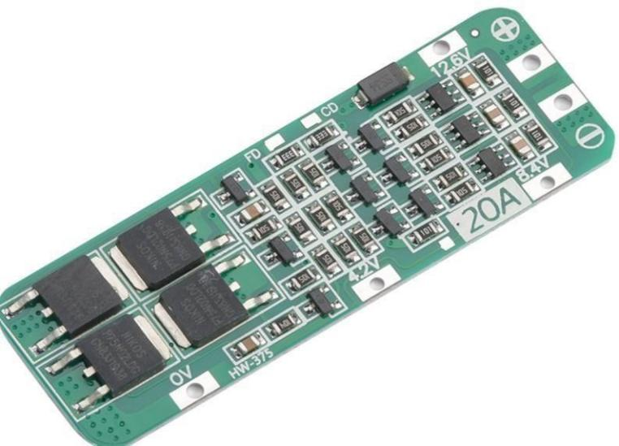

Rocker ON/OFF Switch

A rocker switch is a simple mechanical switch used to control power delivery to the entire system. It works by rocking back and forth to connect or disconnect the circuit. The switch used in this project is a single-pole single-throw (SPST) type, ideal for turning the solar monitoring system ON or OFF manually.

This switch is essential in offering user control over the power source. When the switch is ON, power from the battery or solar input flows to the NodeMCU, sensors, buck converter, display, and other modules. When switched OFF, it completely disconnects the load, preventing unnecessary power consumption and protecting the system during maintenance.

Rocker switches are popular due to their durability, ease of use, low cost, and clear visual indication. Their robust design allows them to handle higher currents compared to small push-button switches, making them suitable for power control applications.

In this solar monitoring system, the switch also helps in safely powering the device during testing phases. It prevents unintentional activation of loads like fans or relays during assembly. Rocker switches are commonly used in power supplies, home appliances, battery boxes, chargers, and control panels.

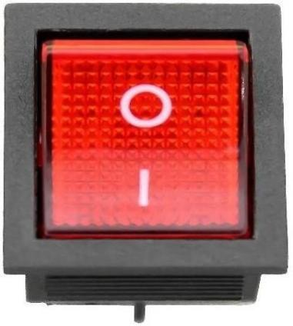

DC Barrel Jack Input Socket

A DC barrel jack is used to provide an external DC power input to the system. It allows the system to be powered by an adapter, charger, or external DC supply when solar power is not available or during testing. The barrel jack ensures a firm and reliable connection, preventing loose contacts.

In solar monitoring systems, the DC jack can serve two purposes:

  - Charging the lithium battery using an external adapter.
  - Powering the entire circuit directly during troubleshooting.

The jack is designed to handle voltages typically between 5V and 24V, depending on the system design. Its simple plug-and-play interface makes it convenient for portable electronics. Internally, the jack consists of two terminals (positive and negative), which connect directly to the BMS or buck converter.

Barrel jacks are preferred in embedded systems due to their durability, ease of use, and polarity control. They prevent reverse polarity connection mistakes, which can damage the circuit.

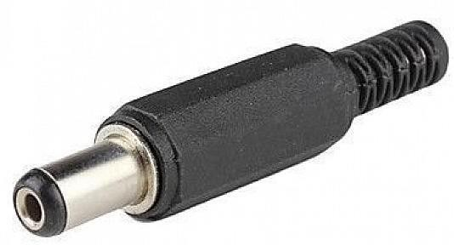

Solar Panel

The solar panel is the primary energy source in this monitoring system. It converts sunlight into electrical energy using photovoltaic (PV) cells made of semiconductor materials, typically silicon. When exposed to sunlight, the PV cells generate direct current (DC) electricity proportional to the intensity of sunlight.

In this IoT system, the solar panel charges the lithium-ion battery and provides power to the NodeMCU, sensors, and other electronics. Solar panels used in small projects usually range from 5W to 20W, producing voltages between 6V and 12V. The generated voltage is then regulated by the buck converter and managed by the BMS for safe charging.

Solar energy is renewable, noise-free, eco-friendly, and ideal for continuous monitoring applications. Its ability to operate independently without grid power makes it suitable for remote or off-grid locations.

The performance of a solar panel is influenced by sunlight intensity, temperature, dust accumulation, and panel orientation. In monitoring systems, a voltage sensor helps track the panel’s output and logs performance data for analysis.
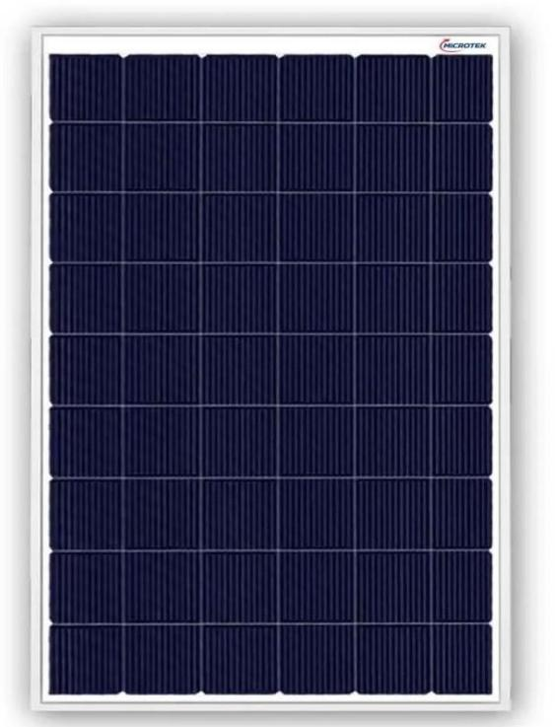

CHAPTER 5

5.1 Arduino IDE
5.2 Blynk App

Arduino IDE

The Arduino Integrated Development Environment (IDE) is a widely used software platform for writing, compiling, and uploading programs to microcontroller boards such as Arduino, ESP8266, and ESP32. It provides a user-friendly interface that simplifies embedded programming, making it accessible for beginners while still powerful enough for advanced developers. The IDE supports C/C++ programming language with built-in libraries, examples, and debugging tools, helping users develop reliable embedded applications efficiently.

In this IoT-based solar power monitoring system, the Arduino IDE is used to write the firmware for the NodeMCU ESP8266 microcontroller. The program includes instructions to read sensor data (voltage sensor, DHT11 temperature and humidity sensor), control the relay module, send data to cloud platforms, and display information on the LCD screen. The IDE allows seamless integration of required libraries such as ESP8266WiFi.h, BlynkSimpleEsp8266.h, Wire.h, LiquidCrystal_I2C.h, and sensor libraries, enabling fast development of connected applications.

One of the major strengths of the Arduino IDE is its extensive community support. Thousands of tutorials, sample codes, and open-source libraries are available, making troubleshooting easy. The software includes features such as serial monitor and serial plotter, which help visualize real-time sensor data during testing and debugging



Blynk App

Blynk is a powerful IoT platform designed to build mobile dashboards for monitoring and controlling smart devices. It allows developers to create real-time control panels using drag-and-drop widgets, making IoT application development fast and user-friendly. Blynk supports popular microcontrollers like ESP8266, ESP32, Arduino, and Raspberry Pi, enabling seamless wireless communication through Wi-Fi, mobile data, or cloud servers.

In this IoT-based solar power monitoring system, the Blynk App serves as the main remote monitoring interface. Through the app, users can view real-time data such as solar voltage, battery percentage, temperature, humidity, and system status from anywhere in the world. Widgets like gauges, charts, value displays, notification panels, and LED indicators help present sensor data clearly and interactively. The app also supports push notifications, enabling the system to alert the user instantly during abnormal conditions like low battery voltage, overheating, or sudden power drops.

Blynk uses an authentication token to link the mobile dashboard with the NodeMCU ESP8266. Once connected, the microcontroller sends data to the Blynk cloud using the Blynk libraries integrated in the Arduino IDE. This ensures fast, secure, and reliable communication.

The platform supports real-time graphs and history charts, helping users analyze long-term solar panel performance. Users can also automate operations—for example, switching the cooling fan ON/OFF using virtual buttons based on sensor conditions.


CHAPTER 6

The IoT-Based Solar Power Monitoring System works by integrating sensors, a microcontroller, communication modules, and cloud platforms to provide real-time monitoring of solar energy generation and consumption. The system begins with the solar panel, which converts sunlight into DC electrical energy. This energy is either supplied directly to the load or stored in the lithium-ion battery pack, which is protected by a BMS (Battery Management System) to ensure safe charging and discharging.

To monitor the system's performance, key parameters such as solar voltage, battery voltage, temperature, and humidity are continuously measured using sensors. The voltage sensor module reads the solar and battery voltages, while the DHT11 sensor captures environmental temperature and humidity. These parameters are fed to the NodeMCU ESP8266, which acts as the system's brain.

The NodeMCU processes the sensor data and transmits it wirelessly to the Blynk cloud platform through Wi-Fi. The Blynk mobile application displays real-time values using widgets like gauges, charts, and value displays. This enables the user to monitor the solar system remotely from anywhere in the world.

The IoT-Based Solar Power Monitoring System operates through the integration of hardware components, sensors, and IoT software platforms to measure, analyze, and display solar power parameters in real time. The following points explain the complete working procedure in detail:

Solar Power Generation

  - The system begins with the solar panel, which absorbs sunlight and converts it into electrical energy using photovoltaic cells.
  - This generated DC power is supplied to the load and simultaneously used to charge the lithium- ion battery pack.
  - The solar output varies based on sunlight intensity, weather conditions, panel direction, and temperature.

Battery Charging and Protection

  - The generated solar energy charges the Li-ion battery pack.
  - A Battery Management System (BMS) regulates the charging and discharging cycles.
  - The BMS prevents overcharging, deep discharge, overheating, and overcurrent to ensure safe battery operation.
  - This ensures the system continues working even when sunlight is not available (e.g., night or cloudy weather).

Voltage and Environmental Monitoring

  - A voltage sensor module continuously measures the voltage of both the solar panel and the battery.
  - The DHT11 sensor gathers environmental temperature and humidity data.
  - The data helps analyze how environmental factors affect solar performance, such as high heat reducing panel efficiency.

Data Processing Using NodeMCU ESP8266

  - All sensor readings are collected by the NodeMCU ESP8266 microcontroller.
  - The microcontroller processes the data, converts analog readings into meaningful values, and packages them for transmission.
  - NodeMCU is chosen due to its built-in Wi-Fi, low power consumption, and ease of programming using Arduino IDE.

Voltage Regulation

  - The system uses an LM2596 buck converter to step down 12V or higher input voltage to 5V or 3.3V for powering the NodeMCU and sensors.
  - This ensures stable and safe operation of all low-voltage components, even when solar voltage fluctuates.

Local Data Display

  - A 16×2 LCD display, often with I2C interface, shows real-time measurements such as:
    - Solar voltage
    - Battery voltage
    - Temperature
    - Humidity
    - System status
  - This allows users to monitor performance on-site even without internet access.

Remote Monitoring via IoT (Blynk App)

  - Using the NodeMCU's Wi-Fi capability, data is sent to the Blynk Cloud Server.
  - The Blynk App displays the parameters through gauges, charts, graphs, and numerical displays.
  - Users can check the solar system status from anywhere in the world using their mobile phone.

Automatic Fan Control Using Relay

  - A relay module is connected to control the 12V cooling fan.
  - When the temperature exceeds a predefined threshold, the NodeMCU activates the relay, turning the fan ON.
  - When temperature goes down, the relay switches the fan OFF.
  - This protects the battery and electronics from heat damage and improves system longevity.

Power Control and External Charging

  - A rocker switch allows manual ON/OFF operation of the full system.
  - A DC jack provides an external charging or power input option when sunlight is insufficient.

CHAPTER-7
CODE

#define BLYNK_TEMPLATE_ID "TMPL3RgjxPWup" #define BLYNK_TEMPLATE_NAME "Solar Monitor"
#define BLYNK_AUTH_TOKEN "Y7U3bqAvb37I0McYFoB8N-qZ8UtTF1bl" #define BLYNK_PRINT Serial
#include <ESP8266WiFi.h> #include <BlynkSimpleEsp8266.h> #include <Wire.h>
#include <LiquidCrystal_I2C.h> #include "DHT.h"
// ----------- Pin Configuration ------------
#define DHTPIN 12 // D6 -> DHT21 Data #define DHTTYPE DHT21
#define RELAY_PIN 13 // D5 -> Relay
#define VOLTAGE_PIN A0 // Analog voltage input #define RELAY_ACTIVE_STATE HIGH
// LCD Setup LiquidCrystal_I2C lcd(0x27, 16, 2);
// DHT Setup
DHT dht(DHTPIN, DHTTYPE);

// ----------- WiFi & Blynk Setup ----------- char auth[] = BLYNK_AUTH_TOKEN; char ssid[] = "Solar_Monitoring";
char pass[] = "123456789";

// ----------- Global Variables -------------
float temperature = 0, humidity = 0, voltage = 0; bool relayState = false; // Relay OFF by default
// ----------- Blynk Relay Control (V3) ----------- BLYNK_WRITE(V3)
{

relayState = param.asInt();
digitalWrite(RELAY_PIN, relayState ? RELAY_ACTIVE_STATE :
!RELAY_ACTIVE_STATE);
lcd.setCursor(0, 1); lcd.print("Relay: ");
lcd.print(relayState ? "ON " : "OFF");
}
// ----------- Sync Blynk on Connect ---------- BLYNK_CONNECTED()
{
Blynk.syncVirtual(V3); // Sync relay state from Blynk app
}
//
void setup() { Serial.begin(115200);
pinMode(RELAY_PIN, OUTPUT);
digitalWrite(RELAY_PIN, LOW); // Relay OFF at start (active-LOW)

lcd.init(); lcd.backlight(); dht.begin();

// --- Startup Display (5 seconds) --- lcd.setCursor(0, 0);
lcd.print("Solar Monitor"); lcd.setCursor(0, 1); lcd.print("Initializing..."); delay(5000);
lcd.clear();
// --- WiFi + Blynk Connect --- lcd.print("Connecting WiFi"); WiFi.begin(ssid, pass);
while (WiFi.status() != WL_CONNECTED) { delay(500);
lcd.setCursor(0, 1); lcd.print(".");

}
lcd.clear();
lcd.print("WiFi Connected!"); delay(2000);
lcd.clear();
Blynk.begin(auth, ssid, pass);
}

void loop() { Blynk.run();
// --- Read Sensors ---
temperature = dht.readTemperature(); humidity = dht.readHumidity();
int adcValue = analogRead(VOLTAGE_PIN);
float sensorVoltage = (adcValue / 1023.0) * 3.3; // ADC ref 3.3V voltage = sensorVoltage * 5.0; // Adjust for voltage divider
// --- Validate DHT Data ---
if (isnan(temperature) || isnan(humidity)) { lcd.clear();
lcd.print("Sensor Error!"); delay(2000);
return;
}
// --- Update LCD --- lcd.clear(); lcd.setCursor(0, 0); lcd.print("T:"); lcd.print(temperature, 1); lcd.print("C H:"); lcd.print(humidity, 0); lcd.print("%");

lcd.setCursor(0, 1); lcd.print("V:"); lcd.print(voltage, 2); lcd.print("V ");
lcd.print(relayState ? "ON" : "OFF");
// --- Send Data to Blynk --- Blynk.virtualWrite(V0, temperature); Blynk.virtualWrite(V1, humidity); Blynk.virtualWrite(V2, voltage); Blynk.virtualWrite(V3, relayState);

delay(2000);
}

CHAPTER-8
RESULTS AND DISCUSSION
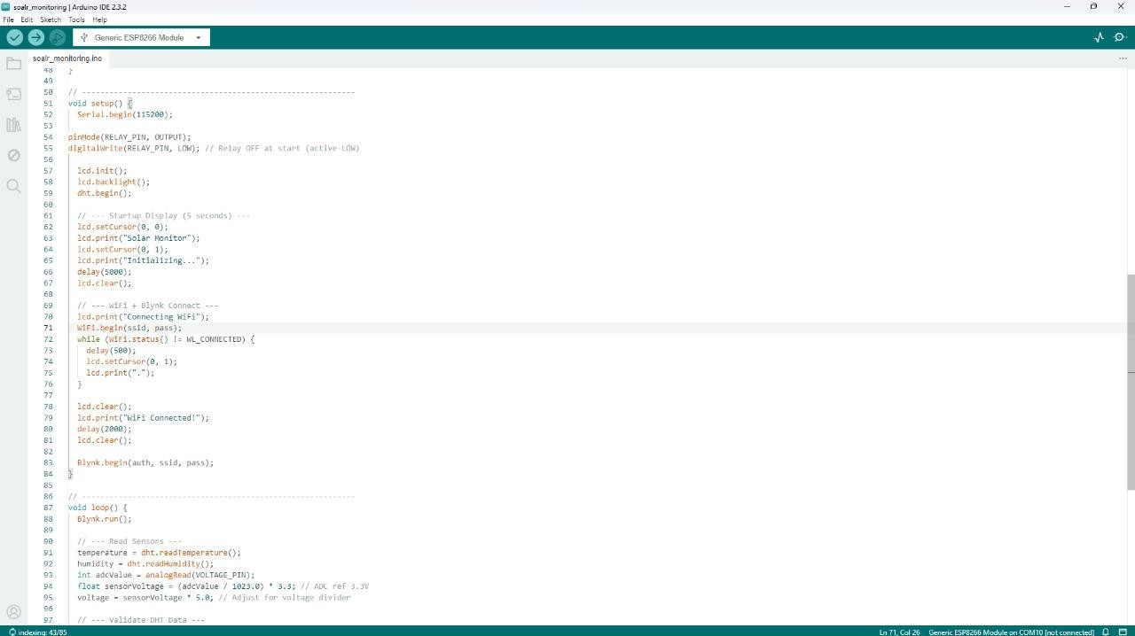

CHAPTER-9
CONCLUSIONS

The IoT-Based Solar Power Monitoring System successfully demonstrates how modern smart technologies can significantly enhance the efficiency, reliability, and usability of renewable energy systems. By integrating sensors, a microcontroller, wireless communication, and cloud platforms, the system offers a comprehensive solution for real-time monitoring and intelligent management of solar power generation and storage.

The system overcomes the limitations of traditional manual monitoring methods by providing continuous tracking of essential parameters such as solar voltage, battery health, temperature, and humidity. Through the NodeMCU ESP8266, data is efficiently processed and transmitted to the Blynk cloud platform, allowing users to access real-time information from anywhere in the world. This remote accessibility not only improves convenience but also ensures quick response to abnormal conditions, thereby preventing potential system failures.

The use of automation—such as temperature-based fan control through a relay—adds an additional layer of protection to the hardware and improves overall system reliability. Local display through the 16×2 LCD ensures that even without internet connectivity, users can still view system performance. The LM2596 buck converter and BMS module ensure safe and efficient power management throughout the system.

Overall, the project highlights the powerful combination of solar energy with IoT technologies to create a smart energy monitoring platform. It improves operational visibility, reduces human intervention, minimizes downtime, and promotes optimal use of renewable energy resources. With this system, users can make informed decisions, improve energy efficiency, and contribute to sustainable living. The project therefore stands as a practical, cost-effective, and scalable solution suitable for homes, industries, and remote installations.

REFERENCES

- Arduino Documentation, “Arduino IDE User Guide,” Arduino.cc, Available at: https://www.arduino.cc/en/Guide
- Espressif Systems, “ESP8266 Technical Reference Manual,” Espressif Official Documentation.
- Blynk IoT Platform, “Blynk Cloud and App Documentation,” Available at: https://docs.blynk.io
- Saeed, K., & Mohammed, A., “IoT-Based Energy Monitoring Systems: A Review,”
International Journal of Smart Grid Technology, 2020.
- Sharma, P. & Singh, R., “Smart Solar Energy Monitoring Using IoT,” International Journal of Engineering Research & Technology (IJERT), Vol. 7, Issue 5, 2019.
- IEEE Xplore, “Applications of IoT in Renewable Energy Systems,” 2018.
- Priya, G., & Kumar, S., “Solar Power Management and Monitoring Using Microcontroller and IoT,” International Journal of Advanced Research in Electronics and Communication Engineering, 2021.
- Open Source Community, “ESP8266 Wi-Fi Module Tutorials and Projects,” Github & Online Forums.
- Texas Instruments, “LM2596 Buck Converter Datasheet,” TI Semiconductor Documentation.
- Adafruit Industries, “DHT11 Temperature and Humidity Sensor Datasheet and Guides,” Adafruit Learning System.
- Green, M., “Solar Photovoltaics: Technology Overview,” Renewable Energy Handbook, 2017.
- TutorialsPoint, “Internet of Things (IoT) Overview and Architecture,” TutorialsPoint.com.

